**INTRAVITREAL INJECTION OF ANTI-VEGF AS A MANAGEMENT OF RETINOPATHY OF PREMATURITY**

***Abstract***

***Introduction:*** *retinopathy of prematurity (ROP) is an ischemic retinopathy occurs on premature and low birth weight infant. It is caused by failure of vascular growth to reach peripheral retina. Intra-vitreal anti-VEGF injection is one of promising management of ROP.*

***Purpose:*** *To present a case of Retinopathy of prematurity that been given intravitreal injection of anti-VEGF*

***Case report:*** *a 30 weeks PMA age boy consulted from pediatric ophthalmology unit with ROP. He was also examined using RetCam imaging. He was diagnosed with ROP zone I stage 2 with plus disease. He was injected with anti-VEGF intravitreally. Physical examination two weeks later showed that the vascular had reached zone III without Plus Disease.*

***Conclusion:*** *Intra vitreal anti-VEGF treatment could be promising for future management of Retinopathy of Prematurity if it was given on the right time (second phase of ROP). Further prospective study is suggested in order to evaluate long term efficacy and adverse event.*

***Key words: Anti-VEGF, Retinopathy of Prematurity, premature infant***

1. **INTRODUCTION**

Retinopathy of Prematurity (ROP) is an ischemic retinopathy occurs on premature and low-birth-weight infants. It was also known as retrolenthal fibroplasia (RLF). It is estimated that ROP caused some degree of visual loss in 1300 children born each year in United States each year and caused severe visual impairment in 250-500 children of those. Approximately 300 children per million live births have at least one eye blinded by ROP.1 Normally retinal vascularization begins to developed within 16 weeks of gestation, and grows centrifugally from the optic disc, reaching nasal ora serrate within eight months of gestation, and temporal ora serrate within one to two months later. Premature birth is a risk factor for ROP, in which normal vascular development is altered and abnormal neovascularization is occur. The pathologic process may stop and reverse itself at any point, or progress eventually and lead to vitreoretinal traction or even retinal detachment.2

Treatment guidelines have been created based on a results of several multicenter ROP trials. Laser photocoagulation has largely replaced cryotherapy as a treatment of choice for ROP in the United States. Laser was used following the same guidelines as those used in former trial and was shown to be equally effective in inducing the regression of the neovascularization and preventing adverse visual sequel.complications following used of cryotherapy and laser are: intense inflammatory response, hyphema, cataract, and glaucoma.2 Laser ablation is currently accepted, safe, and effective therapy for ROP. Two prospective randomized trials have been designed to investigate the efficacy of intravitreal Bevacizumab: Pan-VEGF Blockade for the-Treatment of Retinopathy of Prematurity (BLOCK-ROP) and Bevacizumab Eliminates the Angiogenic Threat of Retinopathy of Prematurity (BEAT-ROP). In the Bevacizumab Eliminates the Angiogenic Threat of Retinopathy of Prematurity Trial (BEAT ROP) by Mintz-Hittner, eyes treated with bevacizumab did exceptionally well with preservation of peripheral retina, completion of retinal neovascularization, and lower recurrence rates.4

This case report is about to show the outcome of intravitreal injection of Anti-VEGF therapy alone used in ROP case. This case was followed up until two weeks after the injections in order to evaluate whether another therapy is needed as an adjunctive treatment.

1. **CASE REPORT**

A month-year-old (30 weeks PMA) boy, was consulted from Pediatric Ophthalmology Unit to Retina and Vitreous Unit of Cicendo National Eye Hospital for anti-VEGF treatment. He came to Pediatric Ophthalmology Unit for screening on 13th of July 2015. He was born a month earlier in Hermina Hospital by Caesarian Section with indication of premature contraction (HIS). Patient was also being incubated for three weeks following birth.

Patient was the second child of his parents. The gestation age was 30-31 weeks with APGAR score 6-8 one minute. He was born with 1625 grams of weight; thirty seven centimeters of height; and 28 centimeters of head circumferential. He was examined by pediatric ophthalmologist and diagnosed with Retinopathy Of Prematurity (ROP).

Mother confirmed that at the time they came, the boy’s age was 30 weeks PMA. there was no serious problem during pregnancy. Mother has never felt sick and trauma during pregnancy. Mother also did not consume any medication or traditional/herbal substance during pregnancy. The first child was born normally without any significance problem on the development and growth.

Vital signs showed pulse was 126 times per minutes; respiratory rate was 35 times per minute; and his temperature was within normal limit. Periodic apnea was not found during examination. Patient was actively move during examination. Blink reflex were positively found on both eyes. Alignment of both eyes was unstable steady maintenance. Physical examination revealed that there were no abnormalities in anterior segment of the eye on both eye. Posterior segment examination showed that retinal vascularization found only in posterior pole (within zone I). There was also fibro-vascular proliferation without ridge on both eyes.

He was also being screened for ROP using RetCam imaging. RetCam imaging result is shown in fig.1. Patient was diagnosed Retinopathy of Prematurity (ROP) Zone I stage II on both eyes. He was then being planned for intravitreal injection of anti-VEGF on both eyes followed by laser on both eyes. Avastin™ was injected 0.025 cc 1.5 mm nasal from limbus on the right eye; and 1.5 mm temporal from the limbus.

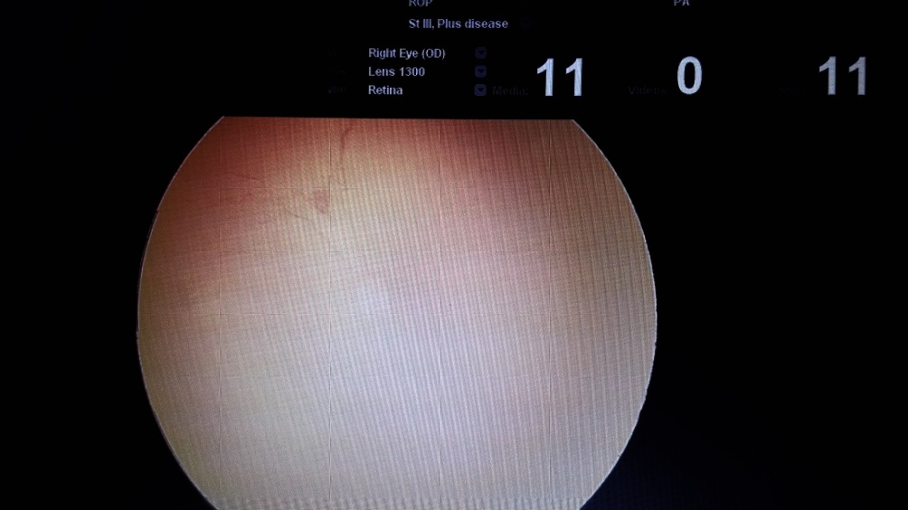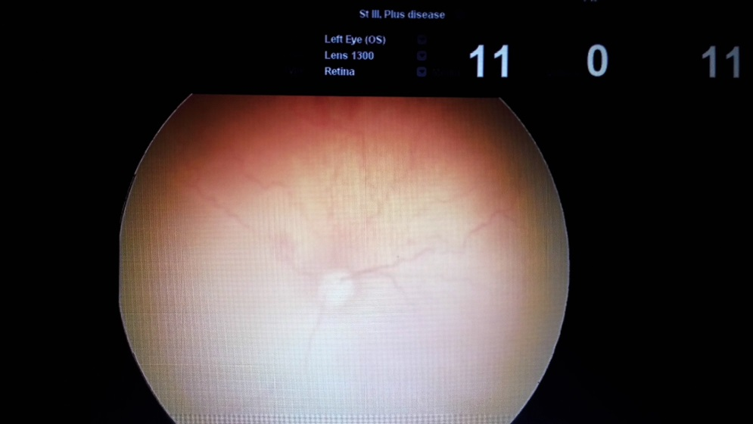

Fig 1. First RetCam Imaging

Patient came to be reexamined on 18th of July 2015. Segment posterior examination showed that retinal vascularization reached zona II (from the edge of zone I to point tangential to nasal ora serrate and around to area near the temporal equator). Ridge was also found on examination. Vascular shunting and arteries tortuosity in the posterior pole was not found during examination. He was then diagnosed with ROP Zone II stage I with Plus Disease. RetCam examination repeated on 22nd July 2015 as seen on fig.2

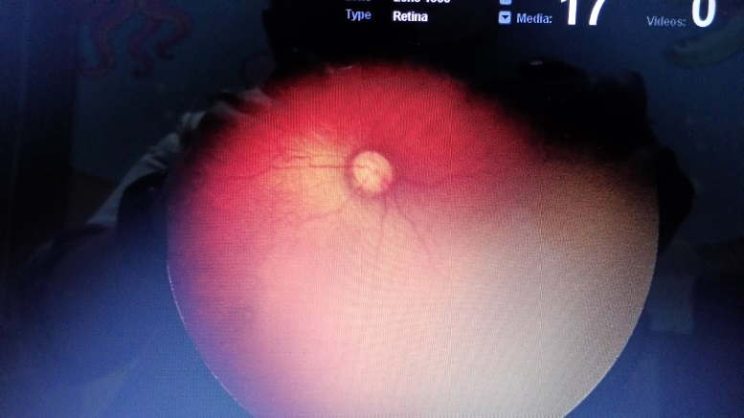 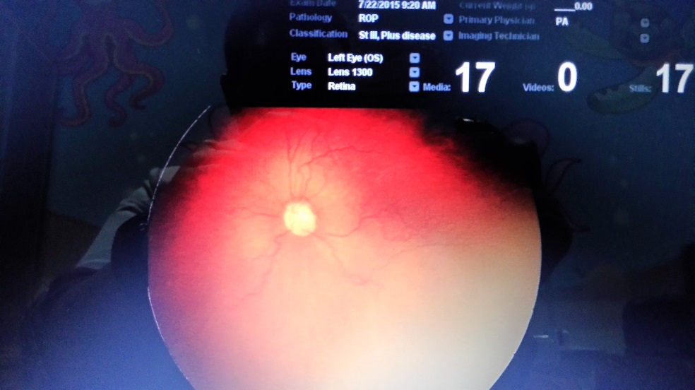

Fig 2. RetCam imaging on 22nd of July 2015

Patient came to follow up on 3rd August 2015, segment posterior examination showed that vascularization reach zone III without any tortuosity. Patient then assessed as ROP zone III stage 1 without Plus Disease (regressed).

1. **DISCUSSION**

Patient was diagnosed with Retinopathy of Prematurity (ROP). Retinopathy of Prematurity (ROP) was first noted in the late 1940s in preterm infants and described as retrolenthal fibroplasia, a total retinal detachment seen as a white mass behind the lens. The disease subsequently associated with excessive oxygen use. The incidence of ROP has increased further due most likely to factors related to prematurity itself as ever more immature infants are saved after preterm birth. Low gestational age at birth and low birth weight were stronger risk factors than controlled oxygen delivery.5

Retinal blood vessel development in the human fetus begins during 4th months of gestation and vessel reach the most peripheral temporal aspect of retina just before term. The retina of infant born prematurely are incompletely vascularized with a peripheral avascular zone the area of which depends on gestational age at birth.5 Michaelson and Cogan suggested that retinal capillaries arise from budding from preexistent arteries and veins that originate from the hyaloid vessels at the nerve head. Ashton suggested that mesenchyme the blood vessel precursor grows from the optic disc through the nerve fiber layer to the periphery of the retina. Provis has demonstrated that expression of VEGF messange in the predicted location in the developing normal human retina, just anrterior to the developed vessel.6

Pathophysiology of ROP divides into two phases. Phase 1 is characterized by vessel, immature vessel that susceptible to oxygen is a part of influence of supplemental oxygen to premature infants, maturation of premature infant resulting in non-vascularized retina becomes increasingly metabolically active and without blood supply leading to hypoxic. Phase II is characterized by hypoxia-induced vascular proliferation, and those new vessel are leaky, and can cause tractional retinal detachments. Phase I happens within birth to 30 weeks PMA; while phase II happens 32-34 weeks PMA.5

Clinical classification devides the retina into three antero-posterior zones and described the extent of disease by the 30-degree meridians (hours of clock) involved. Zones involved divides into Zone I is the posterior pole, or inner zone; zone II extends from the zone I border of zone I to a concentric circle tangential to the nasal ora serrate; and zone III is the remaining rtemporal crescent of the retina anterior to zone II as shown in fig.31,2,6



Fig 3. Retina devided into three zone for Clinical Classification of ROP (source: skuta)2

Staging used in clinical classification of ROP divides into 5 stages. Stage 1 is characterized by the presence of demarcation line as the first patognomonic ophthalmoscope sign of ROP; stage 2 demarcation linehas grown and shows a ridge, small tufts of vessel (popcorn sign) may be seen posterior to the ridge; stage 3 is characterized by extraretinal fibrovascular proliferation tissue; stage 4A shows extrafoveal retinal detachment; stage 4B is characterized by pan retinal detachment involving the fovea; and stage 5 total retinal detachment.1,2,5,6

As shown in the RetCam imaging, patient first diagnosed with ROP zone I stage 2 that showed retinal vessel reach the 30 degree of posterior pole with ridge. After being injected with anti-VEGF, patient was having improvement in vascular growth over the border of zone I. He was then diagnosed with ROP zone II stage II. Patient was followed up to be evaluated the growth of retinal vessel.

Plus disease signifies a more florid form of ROP. Increasing dilation and tortuosity of retinal vessel, iris vascular engorgement, pupillary rigidity, and vitreous haze indicates vascular incompetence. This finding is a key sign of worse prognosis.2,6 Turtuosity of vessel shown in fig.



Fig. 4 Venous and arterial tortuosity (source: Skuta)2

Fundus examination should be examined on infants who have a gestational age of 30 weeks or less; a birth weight of less than 1500 gram; or a birth weight of 1500-2000 g with a supplemental oxygen requirement or unstable course. The first examination should be done at 4 weeks to less than 5 weeks after birth or at a corrected gestational age of 30 to less than 31 weeks. Follow up examination should be done every 1-2 weeks thereafter until retinal vessels have grown normally into zone III or until the risk of developing ROP has passed (about 44-46 weeks PMA).2

This patient first examined by ophthalmologist and being injected with anti-VEGF therapy at his 30 weeks gestational age and still being followed up every 1-2 weeks.

Laser photocoagulation has been used widely over cryotherapy because cryo can further caused rhegmatogen retinal detachment, cataract, hypotony, and iris depigmentation. Laser was also preferred because it can be performed in nursery with only topical anesthesia.5 Based on ETROP trial, laser treatment is strongly recommended on type 1 pretreshold (zone 1 at any stage with plus disease; zone 1 stage 3; and zone 2 stage 2 or 3 with plus disease); type 2 pretreshold (zone 1 stage 1 or 2 without plus disease, zone 2 stage 2 or 3 without Plus disease) should be observed until become type 1 pretreshold.2 ETROP trial yields 9.6% failure rate which is better than former trial. ETROP trial showed that patient with plus disease (vascularly active) need for treatment; and patient with zone 1 disease are worthy to evaluate for treatment because it has large avascular area with likelihood of progression.5 Both cryotherapy and laser treatment currently used is address to destroy the majority of cells that produced VEGF, but inevitably causes permanent visual loss of the peripheral visual field and causes significant myopia due to macular dragging. When multiple application of conventional laser fail to induce regression of retinopathy of prematurity, vitrectomy is required.11

Retinal vascular growth is delayed in premature infant due to the low level of IGF-1 that is required for VEGF signaling. Hyperoxia inhibits vessel formation by suppressing endogenous VEGF production. Non oxygen regulation factors such IGF-1 play a role on ROP. IGF-1 levels low at premature birth, rise with ROP progression, permitting VEGF-induced retinopathy.5,7,8 Timing is critical to any intervention. IGF-1 low levels on phases 1 can suppress neovascularization; but in phase 2, lack of IGF-1 is associated with poor vascular growth with subsequent of proliferative ROP. Inhibition of either VEGF and IGF-1 early after birth can prevent normal blood vessel growth and precipitate the disease, whereas inhibition at the second phase would prevent destructive neovascularization.5 Lutty et al, has demonstated that in dog model of ROP, anti-VEGF blocked simultaneously VEGF and Placental Growth Factor.9 McCloskey et al showed similar result in rodent model.10 It showed that more anti-VEGF blockade is not better but worse, leading to increase avascular retina and delayed atypical neovascularization formation with activation of compensatory angiogenic signals that may respond to subsequent VEGF blockade.10 It is now understood that phase 1 involves relative hyperoxia and decreased VEGF; whereas phase 2 involves relative hypoxia and increased VEGF levels.11

On BEAT ROP, anti VEGF used was bevacizumab. Safety is the primary reason when considering use of intravitreal bevacizumab for an assessment of mortality as compared to the laser treatment is significantly increasing. Compared to any other anti-VEGF available now, Bevacizumab has larger molecule (150 kD) and it is a full antibody that cannot penetrate the intact retina or escape the eye in a very small amount unless laser therapy has destroyed the natural barrier of retina.11 Relative long half life of intravitreal bevacizumab (5-10 days); the highly viscous preterm vitreous gel; and a definitive end point suggest that single injection of bevacizumab (half the dose for adult if ocular neovascular disease, 0.625 mg on 0.025 cc) would be adequate to treat retinopathy of prematurity.11

BLOCK-ROP study (Pan VEGF Blockade for the Treatment of Retinopathy of prematurity was designed to asses the safety and tolerability of bevacizumab in infants with aggressive posterior ROP (APROP) who had failed conventional laser therapy. But phase 1 of trial is terminated due to insufficient enrollment.12 A second phase of BLOCK ROP trial targets all eligible infant (tyope 1-treshold ROP). There are three groups involves in this trial: first group with bevacizumab 0.75 mg on one eye and laser on another; second group 0.625 mg bevacizumab on one eye and laser on another; and third group receive laser treatment on both eye. Ranging dose will aim to demonstrate noninferiority of bevacizumab intravitreal compared to laser treatment.12

Retrospective study of intravitreal anti-VEGF therapy as adjunct to laser treatment once reported by Ozdek et al.13 Intravitreal bevacizumab in addition to standard laser photocoagulation as a salvage therapy or primarily combined with laser of 15 eyes (9 patients) were reviewed. Those had zone I or posterior zone 2 plus disease staging between severe 3 and 4a. disease regressed totally in 6 eyes (40%); stayed stable as 4A in 1 eye (6.7%); progressed to and stabilized at stage 4A in 3 eyes (20%), and progressed to stage 5 in 3 eyes (20%) within 7-10 days after procedure.13 Intravitreal anti-VEGF (ranibizumab) as a monotherapy has been reported by Menke et al.14 Menke presented a case series of 4 premature infants with threshold ROP stage 3 with Plus Disease at zone II. Six months of follow up showed all eyes complete retinal vascularization without any sign of reccurences. One infant was having upper airway infection second day following injection procedure; while three eyes required paracentesis to reduce intraocular pressure after injection and to restore central artery perfusion.14

Adverse events and complication following anti-VEGF intravitreal procedure including: endoftalmitis, intraocular inflammation, retinal detachment, increasing in IOP, and systemic effect including thromboembolic events, myocardial infarction, stroke, hypertension, gastrointestinal perforation, and kidney disease.15 There were no significant complication following intravitreal injection of anti-VEGF in this patient.

1. **CONCLUSION**

Intra vitreal anti-VEGF treatment could be promising for future management of Retinopathy of Prematurity if it was given on the right time (second phase of ROP). Further prospective study is suggested in order to evaluate long term efficacy and adverse event.

**REFERENCES**

1. Skuta GL, Cantor LB, Weiss JS. Basic and Clinical Science Course Section 12 Retina and Vitreous. San Francisco: Lifelong Education for The Ophthalmologist American Academy of Ophthalmology, 2011.
2. Skuta GL, Cantor LB, Weiss JS. Basic and Clinical Science Course Section 6 Pediatric Ophthalmology and Strabismus. San Francisco: Lifelong Education for The Ophthalmologist American Academy of Ophthalmology, 2011.
3. Rechhia FM, Capone A. Update on Anti VEGF monotherapy for ROP. Review of Ophthalmology 8/15/2011. Download at 2/8/2015 14.50 WIB from [www.reviewofophthalmology.com/content/d/retinal_insider/i/1599/c/29628/](http://www.reviewofophthalmology.com/content/d/retinal_insider/i/1599/c/29628/)
4. Azad R. Use of Intravitreal anti-VEGF: Retinopathy of Prematurity surgeons in Hamlet’s dilemma. Articl Indian J Ophthal. 2012;60(1):40
5. Smith LE. Retinopathy of Prematurity: pathophysiology of disease on Retinal Vascular Disease. Editor: Joussen AM, Gardner TW, Kirchhof B, Ryan SJ. Germany: Springer-Verlag Berlin Hewdilberg, 2007, page 392-402.
6. Palmer EA, Phelps DL, Spencer R, Lutty GA. Retnopathy of prematurity on Retina Fourth Edition Edited by Ryan. China: Mosby, Elsevier, 2006.
7. Lu M, D’amico DJ. Anti-VEGF Therapies for Disease of the Retina nad Choroid on Ocular Angiogenesis Disease, Mechanism, and Therapeutics edited by Jink JT. New Jersey: Humana Press, 2006.
8. Angio CTS, Ambati J, Phelps DL. Urinary Vascular Endothelial Growth Factor (VEGF) in Retinopathy of Prematurity and Other Proliferative Retinopathies. APSSPR Pediatric Research (1999) 45, 192A-192A: doi:10.1203/00006450-1999904020-01140.
9. Lutty GA, Mcleod DS, Bhutto I, Wiengand SJ. Effect of of VEGF trap on normal retinal vascular development and oxygen induced retinopathy in the dog. Invest Ophthalmol Vis Sci. 2011;52:4039-4047.
10. McCloskey M, Wang H, Jiang Y, Smith GW, Strange J, Hartnett ME. Anti-VEGF antibody leads to later atypical intravitreous neovascularization and activation of angiogenic pathways in a rat model of ROP. Invest ophthalmol Vis Sci. 2013; 54:2020-2026.
11. Mintz-Hittner HA, Kennedy KA, Chuang AZ. Efficacy of Intravitreal Bevacizumab for Stage 3+ Retinopathy of Prematurity. N Engl J Med 2011; 364:603-615 DOI:10.1056/NEJMoa1007374.
12. Smith LEH. Through the eyes of a child: understanding retinopathy through ROP: The Friendwald Lecture. Invest Ophthalmol Vis Sci 2008;49:5177-5182.
13. Ozdek S, Unlu M, Gurelik G, Hasanreigsoglu B. Intravitreal anti-VEGF Therapy as an Adjuct to Laser Photocoagulation for Severe Aggressive Posterior Retinopathy of Prematurity. J ophtom 2013 Jan;6(1): 51-59 DOI:10.1016/j.optom.2012.08.004
14. Menke MN, Framme C, Nelle M, Berger MR, Strum V, Wolf S. Intravitreal Ranibizumab Monotherapy to Treat Retinopathy Of prematurity Zone II Stage 3 with Plus Disease. BMC Ophtal (2015) 15:20 DOI: 10.1186/s12886-015-0001-7.
15. Falavarjani KG, Nguyen QD. Adverse events and complications Associated With Intravitreal Injection of Anti-VEGF Agents: a review of Literature. Eye (2013): 27, 787-794; doi:10,1038/eye.2013.